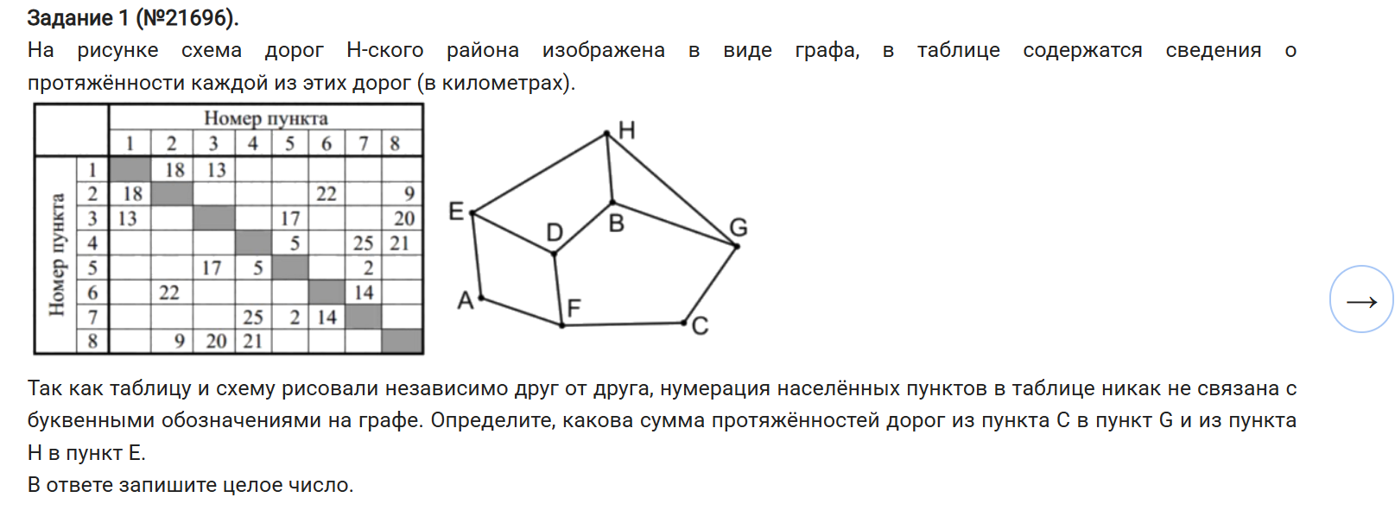

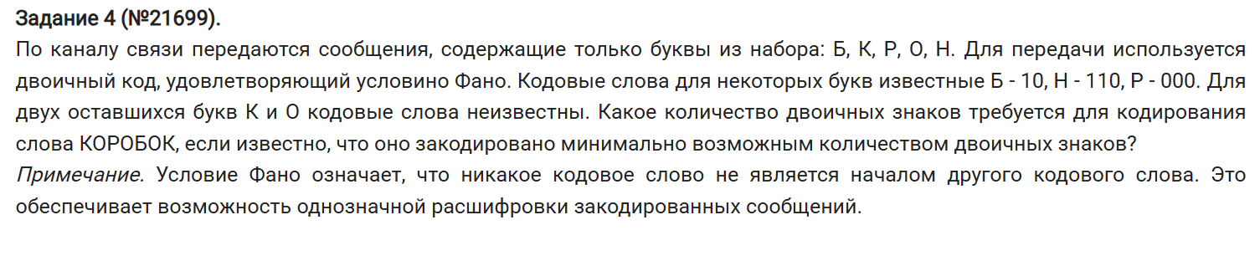

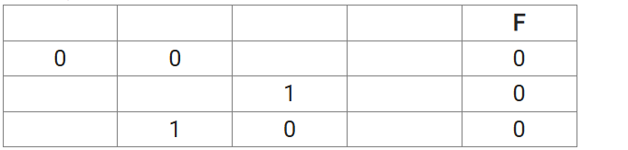

|  |  |  |  |  |
| --- | --- | --- | --- | --- |
| z | y | x | w | f |
| 0 | 0 | 0 | 1 | 0 |
| 0 | 1 | 0 | 1 | 0 |
| 0 | 1 | 1 | 1 | 0 |